客 户 日期

CUSTOMER DATE 2021-11-1

认 可 书

SPECIFICATION FOR APPROVAL
`

客户品名  CUSTOMER P/N | PC95-ATQ22/12
品名  P/N | PC95-ATQ22/12
认可书编号
SPEC.NO.

为保证订单顺利完成，请在一个月内签回，逾期视为默认。
客户认可 APPROVED BY：

如有客户品码（料号），请填写在下

客户品码（料号）：

批准  APPROVED BY | 审核  CHECKED BY | 拟制  PREPARED BY

认 可 书

SPECIFICATION FOR APPROVAL

客户 CUSTOMER: |  |  | P/N | PC95-ATQ22/12
 |  |  | SPEC./N
Ⅰ.更改记录 REVISION RECORD:
 | 版本号  REV NO | 更改内容及原因  CONTENTS AND REASONS | 日期  DATE OF APPROVAL |  | 担当  DRAWN

1. 尺寸DIMENSIONS(mm)
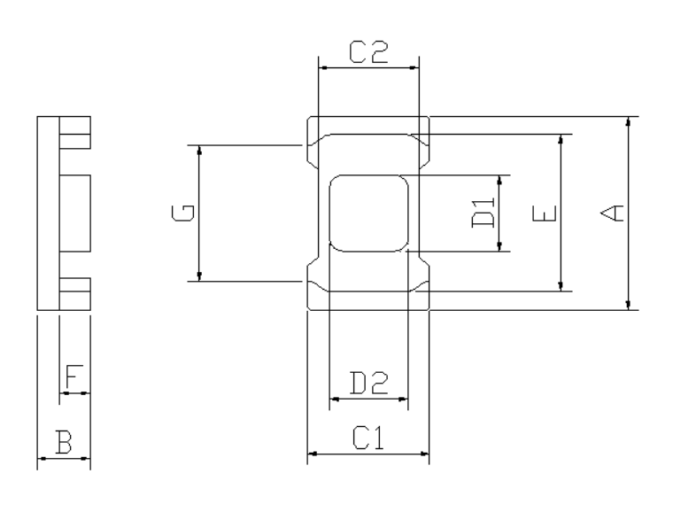 |  | 尺寸  DIMENSIONS(mm)
 |  | A | 22.3±0.5
 |  | B | 6.0±0.2
 |  | C1 | 14.0±0.5
 |  | C2 | 12.0±0.4
 |  | D1 | 8.8±0.3
 |  | D2 | 9.0±0.3
 |  | E | 17.4min
 |  | F | 3.4±0.2
 |  | G | 14.5min
磁芯参数 CORE PARAMETERS
有效磁路长度Effective Length Le | 32.07 mm
有效截面积Effective Cross Area Ae | 66.41 mm²
有效体积Effective Volume Ve | 2129.68 mm³

Item: | P/N: | SPEC./N
FERRITE CORE | PC95-ATQ22/12

2. 电气特性 ELECTRICAL CHARACTERISTICS

项目  ITEMS | 规格  SPEC | 测试条件  TESTING METHOD | 测试仪器  TESTING INSTRUMENT
电感系数AL  INDUCTANCE AL | 5000±25% nH/N² | 1kHz,0.3V, 23±3℃,10Ts | 2810及相关仪器
功率损耗  POWER LOSS | ≤550mw/cm³ | 100kHz,200mT, 100±3℃ | 258及相关仪器

3.材质特性MATERIAL CHARACTERISTICS
材料 MATERIAL：PC95
特性 CHARACTERISTICS |  |  | 单位UNIT |  | 特性质VALUE
初始磁导率  INITIAL PERMEABILITY μi |  |  | ＿ |  | 3300±25%
饱和磁通密度SATURATION MAGNETIC  FLUX DENSITY (H=1194A/m) Bs |  | 25℃ | mT |  | 530
 |  | 100℃ |  |  | 410
剩余磁通密度  REMANENT FLUX DENSITY Br |  | 25℃ | mT |  | 85
 |  | 100℃ |  |  | 60
矫顽力  COERCIVE FORCE Hc |  | 25℃ | A/m |  | 12
 |  | 100℃ |  |  | 9
居里温度  CURIE TEMP. Tc |  |  | ℃ |  | ≥220
电阻率  ELECTRICAL RESISTIVITY ρ |  |  | Ω·m |  | 4
密度  DENSITY d |  |  | kg/m³ |  | 4.9×10³
Item: | P/N: |  |  | SPEC./N
FERRITE CORE | PC95-ATQ22/12

- 材料特性曲线

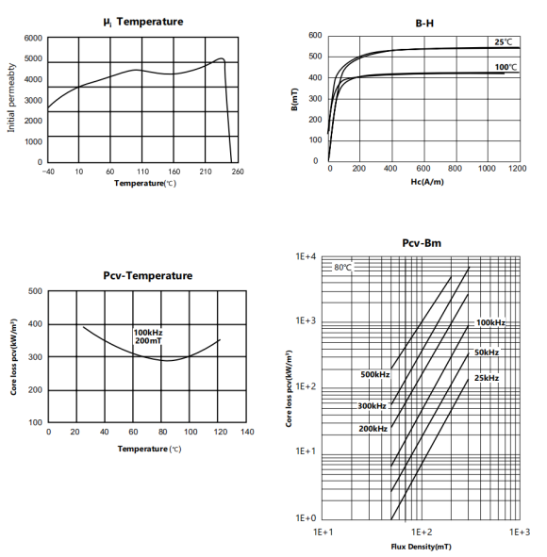

Item: | P/N: | SPEC./N
FERRITE CORE | PC95-ATQ22/12

5. 外观缺陷要求Appearance defects requirements
- 裂纹：正常光照条件下，目视无裂纹
Cracks：In normal lighting conditions, there is no crack on the surface of the product by visual observation.
- 掉块和不规则边缘 Chips and ragged edges
b.1 掉块 Chips
① 配合面掉块：累积面积小于总配合面面积的3%。
The cumulative area of the chips located on the mating surface shall be less than 3% of
the total mating surface.
② 其他表面掉块：累积面积小于总配合面面积的6%。
The cumulative area of the chips located on other surfaces shall be less than 6% of
the total mating surface.
b.2 不规则边缘 Ragged edges
不规则边缘总长度小于相关表面总边长的25%；
The total length of the ragged edges shall be less than 25 % of the perimeter of the relevant
mating surface.

6.检验方法（Inspection Method）
按GB/T 2828.1-2012，一次正常抽样，检查水平Ⅱ，AQL符合下列标准。
According to GB/T 2828.1-2012, one time normal random sampling, Inspect level Ⅱ, AQL should be as follows.
 | 合格质量水平AQL | 检查项目Inspect Item
A | 0.65 | 电磁特性Electromagnetic Property
B | 1.0 | 外形尺寸Outside Size
C | 1.5 | 外观质量Outside Quality

7.包装Packing:
内包装采用泡塑盒，外包装采用纸箱，每箱产品外面都贴上产品合格证（包括品名、数量、批号、检验员）。
The inner packing is made of foam plastic box, the outer packing is made of carton, and the product certificate (including name, quantity, batch number and inspector) is affixed on the outside of each carton.

Item: | P/N: | SPEC./N
FERRITE CORE | PC95-ATQ22/12

